PENINSULA WRESTLING CLUB
PENINSULA WRESTLING CLUB
PWC: 451 W. 20TH AVE., SAN MATEO, CA 94403
(925) 997-3795 & (650) 667.0186 http://www.peninsulawrestlingclub.com

ACKNOWLEDGEMENT & ASSUMPTION OF POTENTIAL RISK
I WISH TO PARTICIPATE IN THE PENINSULA WRESTLING CLUB SPONSORED ACTIVITIES OF FALL, WINTER AND/OR SPRING & SUMMER FOLKSTYLE/FREESTYLE/GRECO WRESTLING. I UNDERSTAND AND ACKNOWLEDGE THAT THESE ACTIVITIES, BY THEIR VERY NATURE, POSE THE POTENTIAL RISK OF SERIOUS INJURY/ILLNESS TO INDIVIDUALS WHO PARTICIPATE. I UNDERSTAND AND ACKNOWLEDGE THAT SOME OF THE INJURIES/ILLNESSES WHICH MAY RESULT FROM PARTICIPATING IN THESE ACTIVITIES INCLUDE, BUT ARE NOT LIMITED TO THE FOLLOWING:
1. SPRAINS/STRAINS 2. FRACTURED BONES 3. UNCONSCIOUSNESS
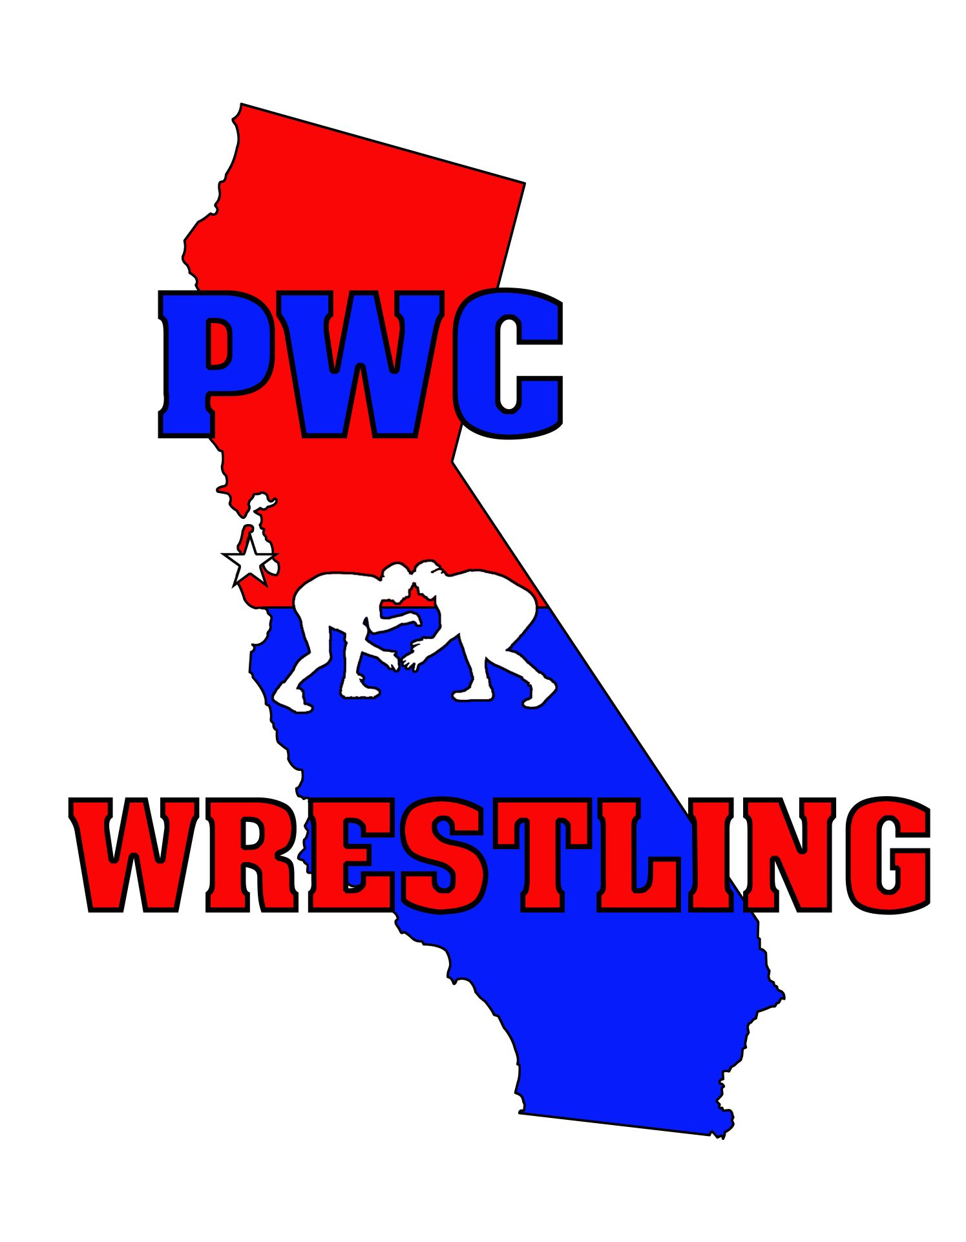
4. HEAD AND/OR BACK INJURIES 5. PARALYSIS 6. LOSS OF EYESIGHT
7. COMMUNICABLE DISEASE/BLOOD BORNE PATHOGEN 8.DEATH
I UNDERSTAND AND ACKNOWLEDGE THAT IN ORDER TO PARTICIPATE IN THESE ACTIVITIES, I AGREE TO ASSUME LIABILITY AND RESPONSIBILITY FOR ANY AND ALL POTENTIAL RISK WHICH MAY BE ASSOCIATED WITH PARTICIPATION IN SUCH ACTIVITIES. I UNDERSTAND, ACKNOWLEDGE, AND AGREE THAT THE PENINSULA WRESTLING CLUB, JUNIPERO SERRA HIGH SCHOOL, ITS EMPOYEES, OFFICERS AGENTS, OR VOLUNTEERS SHALL NOT BE LIABLE FOR ANY INJURY/ILNESS SUFFERED BY MY SON OR DAUGHTER WHICH IS RELATED TO AND/OR ASSOCIATED WITH PREPARING FOR AND/OR PARTICIPATING IN THE ACTIVITIES.
UNLESS OTHERWISE ADVISED, I UNDERSTAND THAT I AM RESPONSIBLE FOR MY OWN TRANSPORTATION TO AND FROM THE ACTIVITIES AND THE PENINSULA WRESTLING CLUB ASSUMES NO LIABILITY FOR LOSS OR INJURY RESULTING FROM MY TRANSPORTAION. ALTHOUGH THE CLUB MAY ASSIST IN COORDINATING THE TRANSPORTATION ANY ASSISTANCE AND/OR RECOMMENDATION PROVIDED IS NOT MANDATORY. IF THE CLUB IS PROVIDING TRANSPORTATION BUT I DO NOT USE THE TRANSPORTATION, I AM RESPONSIBLE TO MAKE MY OWN TRANSPORTATION ARRANGEMENTS AND THE CLUB ASSUMES NO RESPONSIBILITY OR LIABILITY OF ANY KIND.
I HAVE NO KNOWN MEDICAL CONDITIONS WHICH MAY POSE A RISK TO THE HEALTH AND SAFETY OF MY SON, DAUGHTER OR OTHERS BY PARTICIPATING IN THE AFOREMENTIONED ACTIVITY(IES). MY LEGAL GUARDIAN AND I ACKNOWLEDGE THAT WE HAVE CAREFULLY READ THIS ACKNOWLEDGEMENT & ASSUMPTION OF POTENTIAL RISK FORM AND THAT MY SON, DAUGHTER AND I UNDERSTAND AND AGREE TO ITS TERMS.
------------------------------------------------- ----------------------------
Club Mission:
A CLUB DEDICATED TO DEVELOPING KIDS AND
WRESTLING IN THE SAN MATEO COUNTY SINCE 2005.

ATHLETE SIGNATURE DATE:
------------------------------------------------- ------------------------------
LEGAL GUARDIAN SIGNATURE DATE:

PENINSULA WRESTLING CLUB
The Program
MISSION: To Develop kids & Wrestling in San Mateo County.
OBJECTIVE: Our goal is to provide an age appropriate introduction to amateur wrestling. We intend to develop the total athlete and person. To provide kids an opportunity to develop physically, mentally and socially. This program will provide them with the option of specializing in a specific sport in high school or college if they so desire. For kids we utilize a game centered approach to teaching wrestling. The high school program is intended to be a challenging and enjoyable curriculum. Competition is not emphasized. Practice sessions include: social and skill development, strength work, conditioning, position drills, game centered activities and live wrestling.
CURRICULUM:
Elementary and Middle School Levels
*Basic motor, social and personal development.
*A game centered approach to wrestling.
*Beginning to intermediate physical fitness.
*Become familiar with basic Folkstyle, Freestyle and Greco-Roman *A game and skill approach to wrestling.
High School Level
*Intermediate to advance physical fitness.
*Develop basic-adv. Freestyle & Greco-Roman techniques. *Achieve personal and social success in wrestling.
WHEN: Fall 2021 Session: September 10th to November 21st; Winter 2020: January 11th-27th; Spring 2020: Mar. 8th to May 19th Tuesday and Thursdays 5:30- 6:30pm High School- March 8th to June 1st 3:30-4:30pm
WHERE: Junipero Serra High School – Wrestling Room
451 W. 20th Ave. (Under stadium bleachers)
San Mateo, CA 94403
PENINSULA WRESTLING CLUB
ATHLETE EMERGENCY CARD
USAW # & (Temporary password) T-shirt size: Short size:

Last name (Print) First name Date of birth (mm-dd-yy)

School Grade (K-12) Home phone number
Address Zip code E-mail address
Mother’s name Work phone number Cell phone number

Father’s name Work phone number Cell phone number
In case of emergency contact (Please call the following people if the parents cannot be reached.)
Name Relationship Phone number
Insurance

COSTS: $200 Club fee includes: Payments to: The Peninsula Wrestling Club *USA Wrestling Competitor’s Membership Card ($50 value) *Experienced & qualified instruction  *Sessions for Sept-Nov, Jan &, Mar-June  *Team gear and socials  STAFF: Mike Klobuchar Andre Monney  (650) 382-3705 (650) 667.0186  peninsulawrestlingclub@gmail.com andre.monney@yahoo.com |  | Medical Insurance Co. Phone number Policy number
 |  | Dentist Phone number Policy number
 |  | Allergies or limitations:

